Instrument Calibration – Lab 7:

Date Performed: 04/04/2023

Lab Instructor’s name: Mark Vanpoppelen

**Honor Statement:**

An essential feature of the University of Tennessee, Knoxville, is a commitment to maintaining an atmosphere of intellectual integrity and academic honesty. As a student of the university, I pledge that I will neither knowingly give nor receive any inappropriate assistance in academic work, thus affirming my own personal commitment to honor and integrity.

I understand that inappropriate assistance includes:

* Using past lab data
* Using lab data from another section (unless approved by your instructor)
* Using the text from past lab reports
* Using text from another student’s lab report

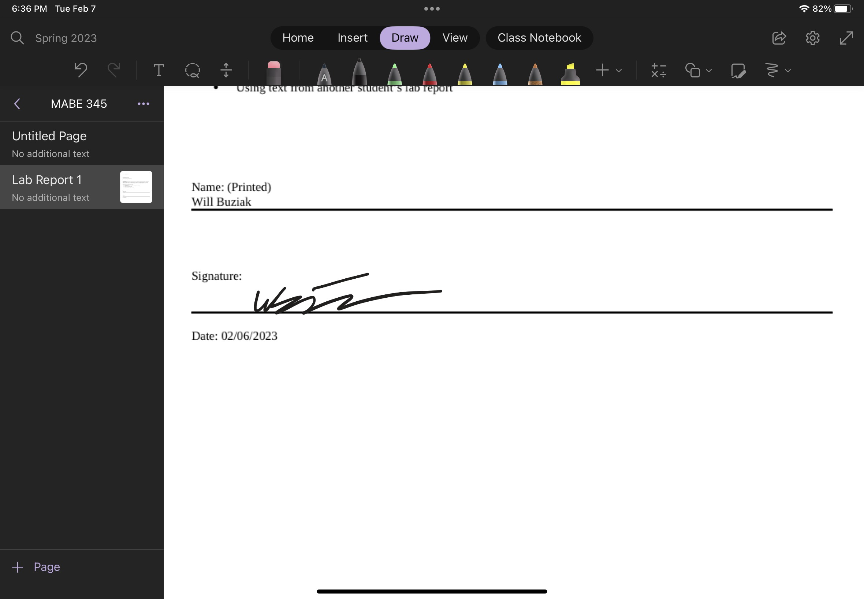

# ABSTRACT

*Will Buziak*

*(Dept. of Mechanical, Aerospace and Biomedical Engineering, University of Tennessee, Knoxville)*

Lab Report #7 – Temperature

The temperature lab introduces students to the methods involved in measuring temperature from measured values. Utilizing the relationships between voltage and change in temperature, the student will utilize a Matlab code to collect voltages corresponding to temperature of a thermocouple within an oven. The different meters utilized in the experiments take advantage of thermal resistance in a wire due to temperature. Thermistors and RTD’s fall into the category that utilizes electrical resistance while thermocouples operate off different electrothermal properties involving it’s materials. The student, as always, walks through the errors associated in the attempt to calibrate the measurement devices and will ideally be able to support the experiment’s real world applications with the associated mathematical theories.

# INTRODUCTION

The first experiment seeks to calibrate each meter to read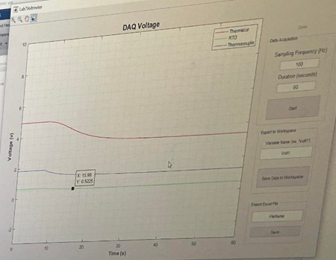 temperature from the measured voltage reading. The voltage readings will be read using a provided Matlab code and will be read each minute. The meters will be placed in an oven after an initial temperature reading of the room. The oven will progressively increase in temperature to 40 degrees C at which point the Matlab code will begin to collect the voltages. Experiment 2 requires the meters be left in the oven at 120 degrees Celsius before being plunged into an ice bath. The Matlab code should collect readings until steady state for each meter. What are the ideal temperature ranges for each meter and is there a response time associated?

## Theory

The beauty in the verboseness of thermodynamics is that you have many tools to approach measuring the temperature and change in temperature of a given environment. The most obvious property to utilize would be the difference in the thermal expansion of two different substances, in many cases, that substance being two metals or a “thermocouple”. The two metals, if “dissimilar” will create a small electro-magnetic field where they come into contact another highly utilized property is the change in electrical resistance due to heat. The thermocouple uses an ice bath to “calibrate” with the constant temperature of 0 degrees Celsius. Of the many methods of using electrical resistance is an “RTD” or “Resistance Temperature Detector” and in many applications utilizes a wheatstone bridge and more bridges can be added to reduce the error. A common downside to RTD’s is their slow response times. This can be mitigated with smaller wires or other methods like a Thermistor, which is similar but has a greater resistance change. Thermistors do not require a wheatstone bridge and are made with ceramic-like semiconductors and therefore many of the specific properties for a given thermistor are dependent upon the materials it is composed and manufactures determine the properties.

# Results and Discussion

Each method of measurement comes with it’s own thermoelectric properties inherited from the thermodynamic principles utilized to make each method work. As a result, there are temporal elements to each method that impact the time constant of each meter’s reading. For instance, the thermocouple had the largest time constant of 8.86 seconds. This is not a surprise, since the thermocouple operates on the temperature of two metals and depending on the materials and the size of the thermocouple, it will take longer to reach a “dissimilar” temperature than it would to otherwise heat or cool a relatively small wire or, even more so a ceramic-like semiconductor of a Thermistor. The benefit of using a Thermocouple, despite it’s longer time constant, is that it is more suitable for high temperature applications like measuring the temperatures of machine parts in intense environments during the design phase. While Thermistors are highly sensitive at lower temperature ranges. Thermistors are suitable for lower temperature ranges while RTD’s are ideal for measuring temperature in the negative Celsius range.

# Conclusion

## Temperature and temperature change are phenomena that must be carefully measured within real world engineering applications due to the potentially catastrophic issues that can be a result of poor thermal management. As a result, it is desirable to have a reliable method of measuring the temperature in a given area. It is the job of the practicing engineer to determine which method of measurement is not just accurate within the scope of the environment at hand, but time and therefore cost efficient. The importance of each of these measurement methods is that each one utilizes different thermodynamic material properties to measure the voltage with a temperature relationship. These methods are reliable and in use as industry standards for temperature measurement.

References

1. M. Vanpoppelen, “MABE 345 Lab Report Required Sections.docx” U.S., Knoxville, TN, 2023.
2. V. Aloi. (2023, February). ME/AE/BME 345 Instrumentation and Measurements class notes. [Online]. Available e-mail: valoi@utk.edu
3. Omega “What Is A Thermistor And How Does It Work?” (Accessed 2023,April) Available online: <https://www.omega.com/en-us/resources/thermistor>

Appendix A: Equipment Information

1. DAQ
2. Thermristor
3. RTD
4. Thermocouple
5. Matlab
6. Ice bath
7. Oven

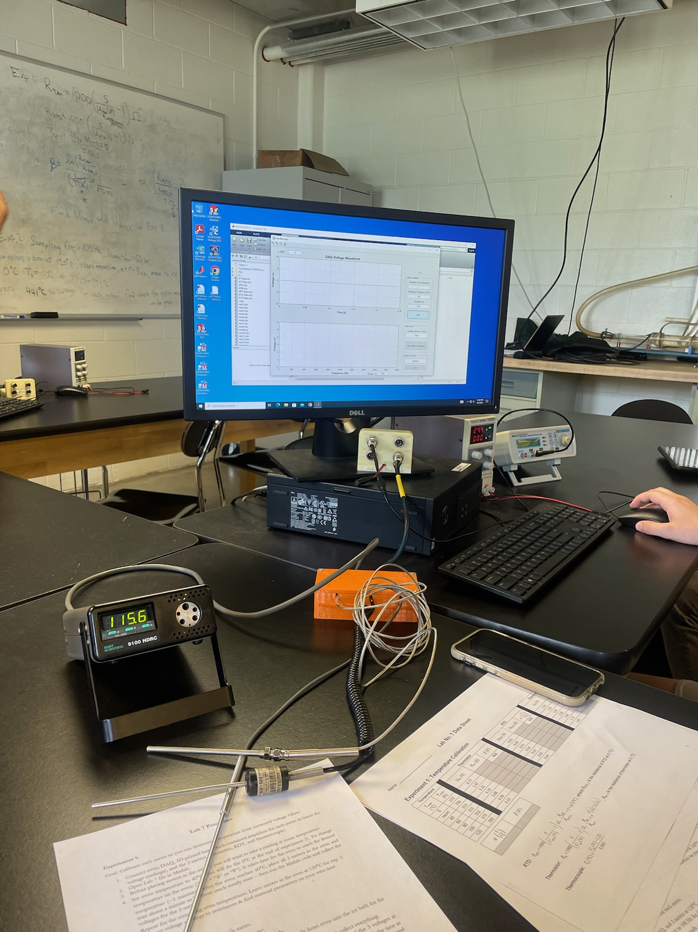

Appendix B: Handwritten Calculations

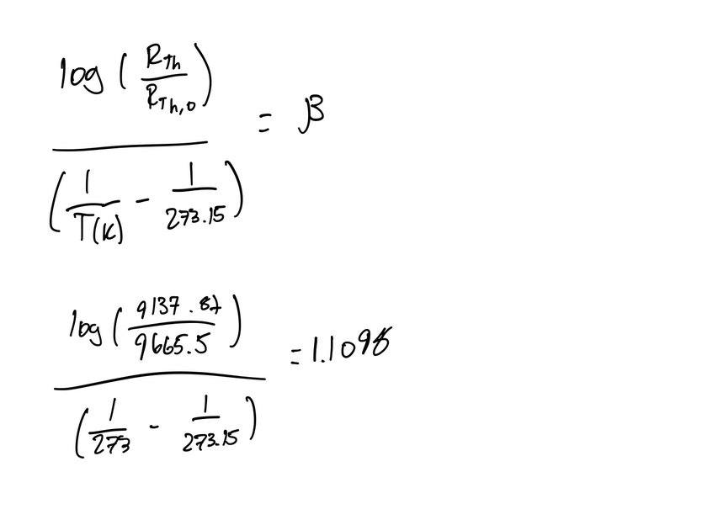

Appendix C: Complete Data Sheet (data continued on hand written sheet)

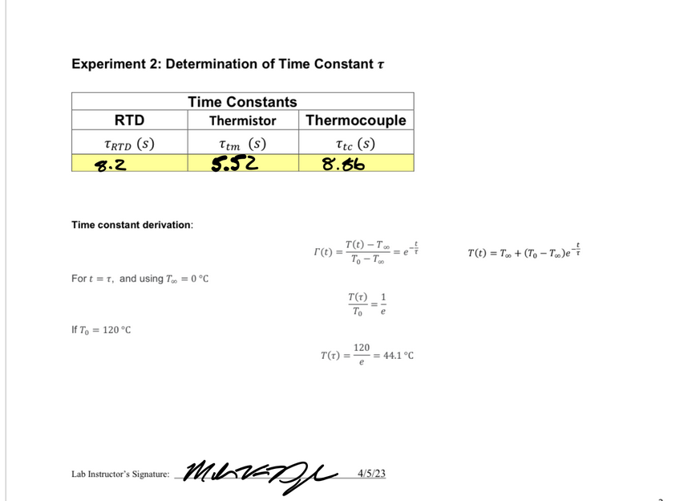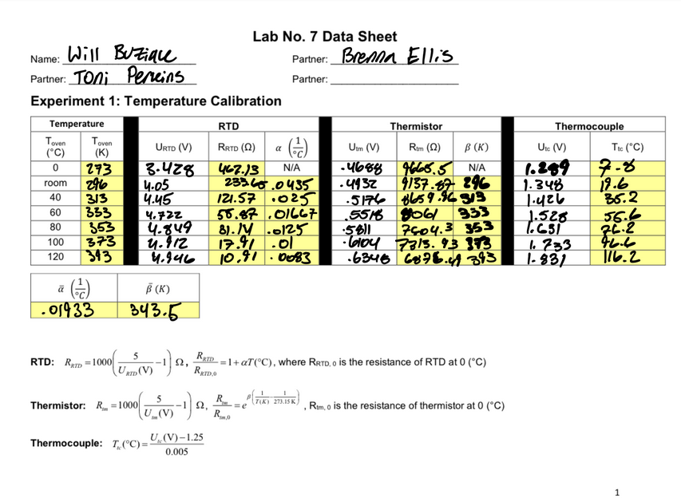

A

Figure C

Experiment 2.

Zero Mass Measurements

Figure F

Instructor Signature